Supplementary File

Supplement to: Rosaudyn R, Mutiani F, Yuliati I, Indraprasta BR. Prognostic role of neutrophil-to-lymphocyte ratio and fibrinogen levels according to the overall survival and progression-free survival in ovarian cancer: a meta-analysis and systematic review. Med J Indones. 2023;32(2):86−97. DOI:10.13181/mji.oa.236880

This file provides further information related to the study.

Supplementary Information

Supplementary Tables
Table S1. Characteristic of high NLR, and high plasma fibrinogen | 2
Supplementary Figures
Figure S1. Forest plots showing HR of OS in multivariate analysis for NLR in subgroup analysis based on treatment specific including surgery | 7
Figure S2. Forest plots showing HR of PFS in multivariate analysis for NLR in subgroup analysis based on treatment specific including surgery | 7
Figure S3. Forest plots showing HR of OS in multivariate analysis for fibrinogen in subgroup analysis based on treatment specific including surgery | 8
Figure S4. Forest plots showing HR of PFS in multivariate analysis for fibrinogen in subgroup analysis based on treatment specific including surgery | 8
Figure S5. Funnel plots of HR of NLR according to the OS in multivariate analyses (horizontal axis) and the SE for the HR (vertical axis) | 9
Figure S6. Funnel plots of HR of NLR according to the PFS in multivariate analyses (horizontal axis) and the SE for the HR (vertical axis) | 9
Figure S7. Funnel plots of HR of plasma fibrinogen according to the OS in multivariate analyses (horizontal axis) and the SE for the HR (vertical axis) | 10
References | 11

Table S1. Characteristic of high NLR and high plasma fibrinogen
First author, year | Laboratory test data | High NLR or fibrinogen characteristic
 |  | n (%) | Age (years), median/mean/ratio (range/SD/n [%]) | CA125 U/ml, median/mean/ratio (range/SD/n [%]) | FIGO stage at diagnosis, n (%) | Histology, n (%)
NLR
Henriksen,¹ 2020 | Prior to treatment of recurrent disease | 35 (50.7) | 68 (47–92) | 487 (6–30.1) | NA | 1. HGSC: 31 (88)  2. LGSOC: 1 (3)  3. Endometrioid: 2 (6)  4. Mucinous: 1 (3)
Marchetti,² 2021 | Prior to treatment | 201 (50.7) | 59.8 (30–85) | 1,973 (3,190) | 1. III: 138 (70.4)  2. IV: 58 (29.6) | HGSOC
Asher,³ 2011 | Prior to surgery | NA | 62 (24–90) | NA | NA | NA
Komura,⁴ 2018 | Prior to primary surgery | 142 (41.3) | 1. <50: 58 (40.8)  2. ≥50: 84 (59.2) | 1. <500: 68 (47.9)  2. ≥500: 74 (52.1) | 1. I–II: 56 (39.4)  2. III–IV: 86 (60.6) | 1. Serous: 59 (41.5)  2. Clear cell: 33 (33.2)  3. Endometrioid: 23 (16.2)  4. Mucinous: 6 (4.2)  5. Others: 21 (14.8)
Wang,⁵ 2016 | Prior to primary surgery | 49 (34.3) | 1. ≤50: 21 (41.2)  2. >50: 30 (58.8) | 1. ≤35: 5 (9.4)  2. >35: 48 (90.5) | 1. I–II: 12 (22.6)  2. III–IV: 41 (77.5) | 1. Epithelial: 45 (85)  2. Non-epithelial: 8 (15)
Baert,⁶ 2018 | Prior to primary treatment | 53 | NA | NA | NA | HGSOC
Miao,⁷ 2016 | Prior to primary surgery | NA | NA | NA | NA | NA
Zhou,⁸ 2018 | Prior to primary surgery | 190 (51.3) | NA | 1. <1,000: 124 (46.1)  2. 1,000–5,000: 57 (66.3)  3. >5,000: 9 (60) | IIIC | 1. Serous: 123  2. Endometrioid: 23  3. Mucinous: 2  3. Clear cell: 3  4. Adenocarcinoma, not otherwise specified: 39
Badora-Rybicka,⁹ 2016 | Prior to chemotherapy | NA | NA | NA | NA | NA
Salman,¹⁰ 2020 | Prior to NACT | 33 (29.7) | 67.0 (11.1) | 2,306 (3,596) | 1. IIIC: 27 (81.8)  2. IV: 6 (18.8) | 1. Papillary serous: 19 (57.6)  2. Endometrioid: (-)  3. Other: 1 (3)  4. Unknown: 13 (39.4)
Jeerakornpassawat,¹¹ 2020 | Prior to initial treatment | 152 (49.7) | NA | 1. <365 IU/l: 57  2. ≥365 IU/l: 95 | 1. I/II: 49 (32.2)  2. III/IV: 103 (67.7) | 1. Serous: 73 (49.0)  2. Non-serous: 79 (51.0)
Cho,¹² 2009 | Prior to surgery, but there were 8 patients was recurrence disease | NA | NA | NA | NA | NA
Feng,¹³ 2016 | Prior to primary surgery | 440 (50.3) | 1. <56: 234 (53.2)  2. ≥56: 206 (46.8) | 1. <500: 53 (12.1)  2. ≥500: 375 (85.2) | 1. I/II: 20 (4.5)  2. III/IV: 420 (95.5) | HGSOC
Wang,¹⁴ 2014 | Prior to primary surgery | 31 (24.6) | 1. ≤50: 15 (48.4%)  2. >50: 16 (51.6%) | 1. ≤35: 2 (6.45%)  2. >35: 29 (93.5%) | 1. I/II: 3 (9.7%)  2. III/IV: 28 (90.3%) | 1. Serous ovarian cancer  2. Low grade: 9 (29%)  3. High grade: 22 (71%)
Li,¹⁵ 2017 | Prior to primary surgery | 111 (32.4) | NA | NA | NA | High grade serous ovarian cancer
Kim,¹⁶ 201⁹ | Prior to NACT | NA | 1. ≤65: 72 (76.6)  2. >65: 22 (23.4) | 1. ≤2,000: 49 (52.1)  2. ≥2,000: 44 (46.8)  3. Missing: 1 (1.1) | NA | Advanced epithelial ovarian cancer
John-Olabode,¹⁷ 2021 | Prior to primary treatment | 1. OS: 45 (48.4)  2. PFS: 38 (40.8) | NA | NA | NA | NA
Williams,¹⁸ 2014 | Prior to primary treatment (surgery for pelvic mass and after diagnosis was made) | NA | NA | NA | NA | NA
Fibrinogen
Qiu,¹⁹ 2012 | Prior to primary surgery | 49 (36) | 1. <50: 23 (47)  2. ≥50: 26 (53) | 1. ≤500: 24 (49)  2. >500: 25 (51) | 1. I: 6 (12.2)  2. II: 4 (8.1)  3. III: 36 (73.5)  4. IV: 3 (6.1) | 1. Serous: 29 (59.2)  2. Mucous: 2 (4.1)  3. Other: 18 (36.7)
Li,²⁰ 2017 | Prior to primary surgery | 82 (44.1) | 60.0 (52.1–67.3) | 600 (20.6.2–1,754.1) | 1. I/II: 11 (13.4)  2. III/IV: 71 (86.6) | 1. Epithelial ovarian cancer  2. Low: 19 (23.2)  3. Middle/high: 63 (76.8)
Polterauer,²¹ 2009 | Prior to surgery | NA | NA | NA | NA | Epithelial ovarian cancer (not classified)
Hu,²² 2020 | Prior to treatment | 29 (27.9) | 1. ≤55: 12 (41.4)  2. >55: 17 (58.6) | NA | 1. I/II: 7 (24.1)  2. III/IV: 22 (75.9) | 1. Serous: 23 (79.3)  2. Non-serous: 6 (20.7)
Feng,²³ 2016 | Prior to surgery | 332 (45.9) | 1. <56: 177 (53.3)  2. ≥56: 155 (46.7) | 1. <500: 53 (16)  2. >500: 272 (84) | 1. I/II: 12 (3.6)  2. III/IV: 320 (96.4) | HGSOC
Zhang,²⁴2015 | Prior to surgery | NA | NA | NA | NA | NA
Man,²⁵ 2015 | Prior to treatment | 80 (42.11) | 1. ≤55: 34  2. >55: 46 | NA | 1. I/II: 29  2. III/IV: 51 | 1. Serous: 41  2. Non-serous: 39
Liu,²⁶ 2015 | Prior to primary surgery | 46 (36.8) | NA | NA | NA | Serous ovarian cancer
Luo,²⁷ 2017 | Prior to treatment | NA | NA | 4,442.5 | Advanced stage | Epithelial ovarian cancer (not classified)
FIGO=The International Federation of Gynecology and Obstetrics; HGSC=high-grade serous carcinoma; HGSOC=high-grade serous ovarian cancer; LGSOC=low-grade serous ovarian cancer; NA=not available; NACT=neoadjuvant chemotherapy; NLR=neutrophil-to-lymphocyte ratio; OS=overall survival; PFS=progression-free survival; SD=standard deviation
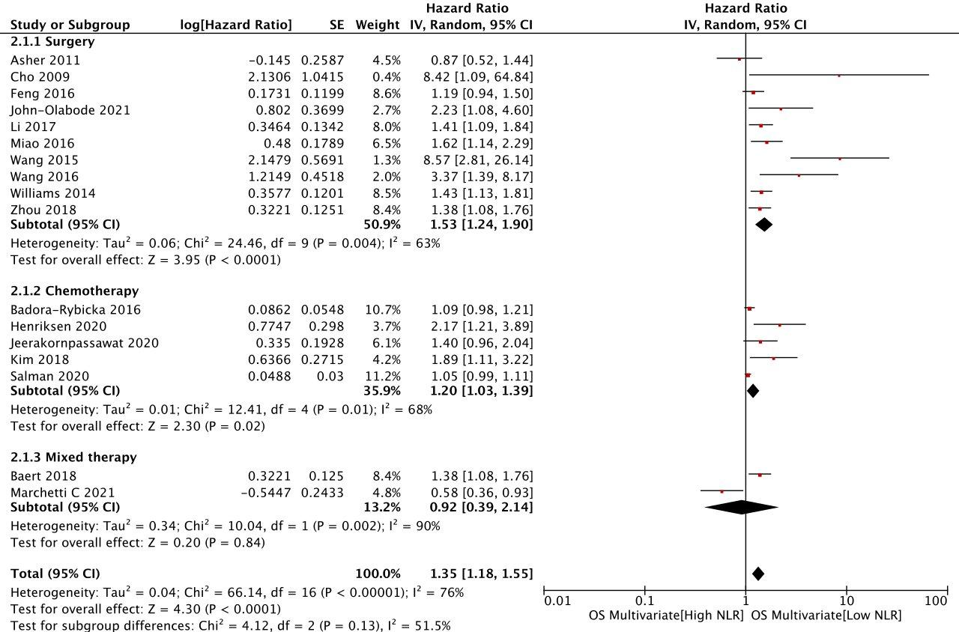
Figure S1. Forest plots showing HR of OS in multivariate analysis for NLR in subgroup analysis based on treatment specific including surgery. CI=confidence interval; HR=hazard ratio; NLR=neutrophil-to-lymphocyte ratio; OS=overall survival; SE=standard error

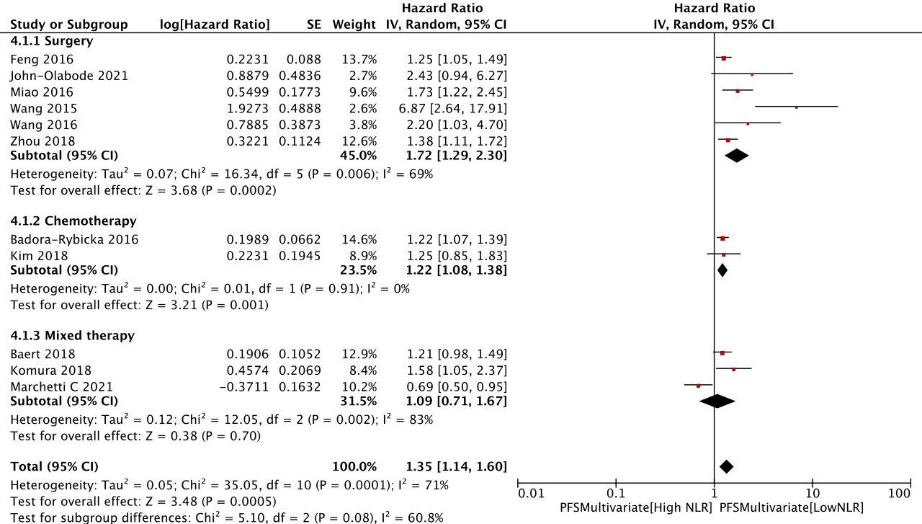
Figure S2. Forest plots showing HR of PFS in multivariate analysis for NLR in subgroup analysis based on treatment specific including surgery. CI=confidence interval; HR=hazard ratio; NLR=neutrophil-to-lymphocyte ratio; PFS=progression-free survival; SE=standard error

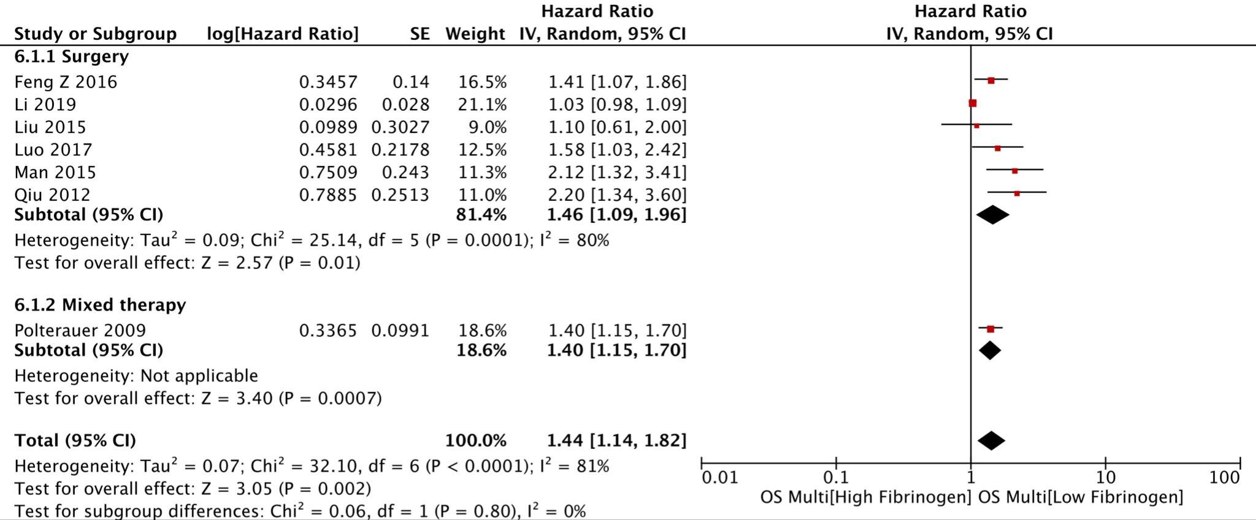
Figure S3. Forest plots showing HR of OS in multivariate analysis for fibrinogen in subgroup analysis based on treatment specific including surgery. CI=confidence interval; HR=hazard ratio; OS=overall survival; SE=standard error

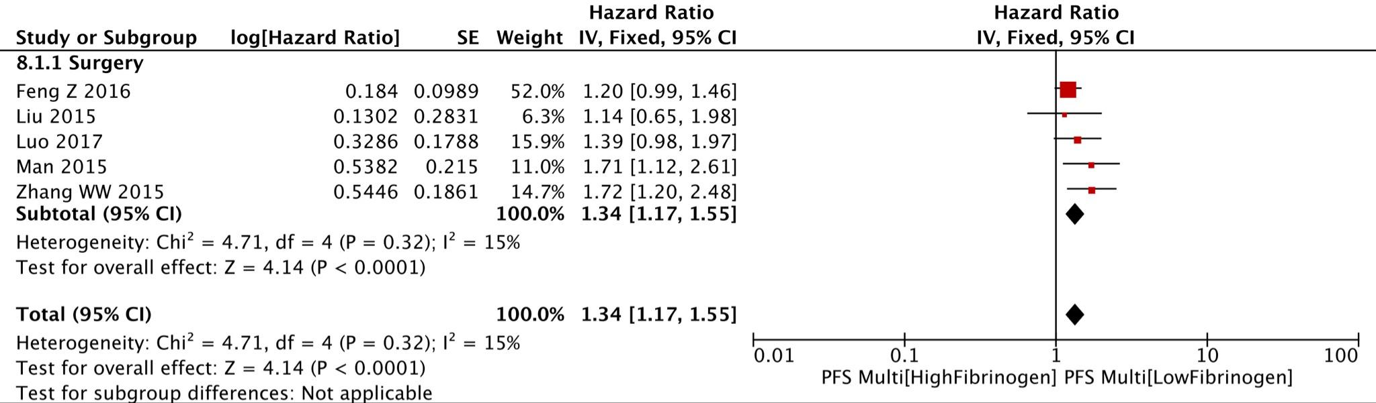
Figure S4. Forest plots showing HR of PFS in multivariate analysis for fibrinogen in subgroup analysis based on treatment specific including surgery. CI=confidence interval; HR=hazard ratio; PFS=progression-free survival; SE=standard error

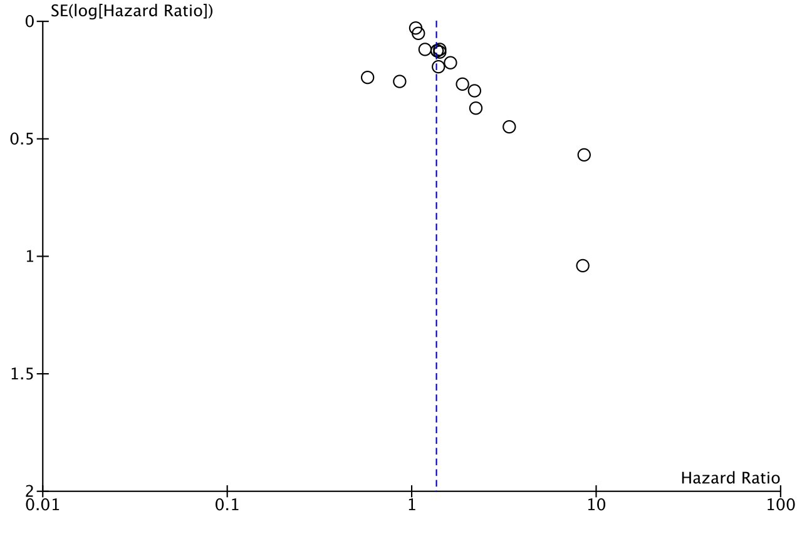
Figure S5. Funnel plots of HR of NLR according to the OS in multivariate analyses (horizontal axis) and the SE for the HR (vertical axis). HR=hazard ratio; NLR=neutrophil-to-lymphocyte ratio; OS=overall survival; SE=standard error

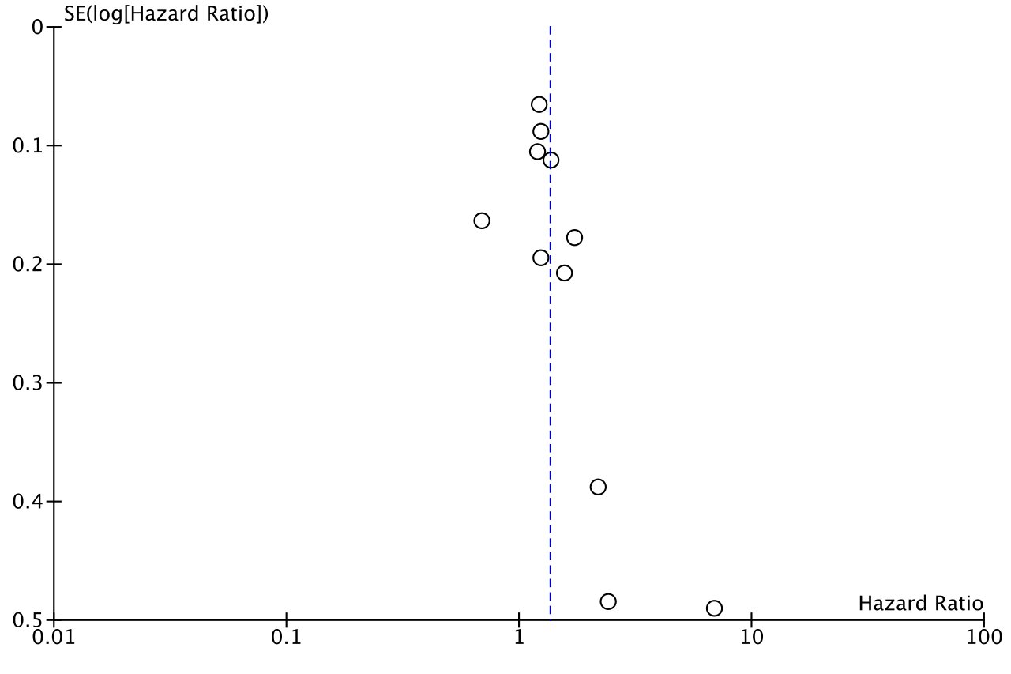
Figure S6. Funnel plots of HR of NLR according to the PFS in multivariate analyses (horizontal axis) and the SE for the HR (vertical axis). HR=hazard ratio; NLR=neutrophil-to-lymphocyte ratio; PFS=progression-free survival; SE=standard error

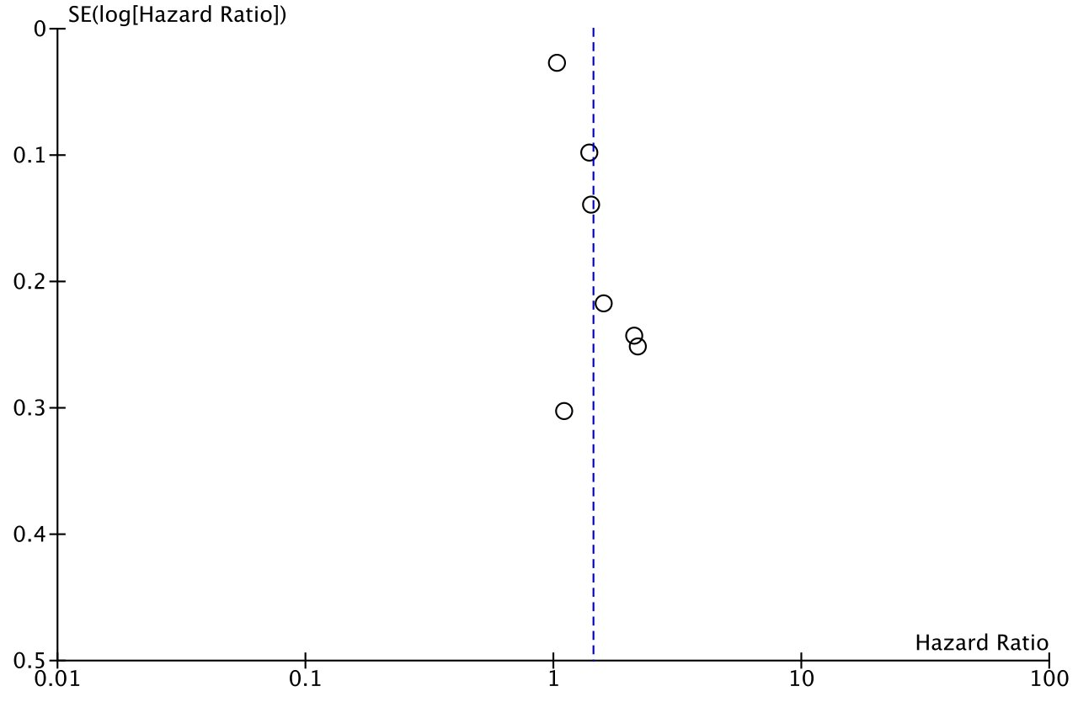
Figure S7. Funnel plots of HR of plasma fibrinogen according to the OS in multivariate analyses (horizontal axis) and the SE for the HR (vertical axis). HR=hazard ratio; NLR=neutrophil-to-lymphocyte ratio; OS=overall survival; SE=standard error

References
- Henriksen JR, Nederby L, Donskov F, Waldstrøm M, Adimi P, Jakobsen A, et al. Prognostic significance of baseline T cells, B cells and neutrophil-lymphocyte ratio (NLR) in recurrent ovarian cancer treated with chemotherapy. J Ovarian Res. 2020;13(1):59.
- Marchetti C, D'Indinosante M, Bottoni C, Di Ilio C, Di Berardino S, Costantini B, et al. NLR and BRCA mutational status in patients with high grade serous advanced ovarian cancer. Sci Rep. 2021;11(1):11125.
- Asher V, Lee J, Innamaa A, Bali A. Preoperative platelet lymphocyte ratio as an independent prognostic marker in ovarian cancer. Clin Transl Oncol. 2011;13(7):499–503.
- Komura N, Mabuchi S, Yokoi E, Kozasa K, Kuroda H, Sasano T, et al. Comparison of clinical utility between neutrophil count and neutrophil-lymphocyte ratio in patients with ovarian cancer: a single institutional experience and a literature review. Int J Clin Oncol. 2018;23(1):104–13.
- Wang YQ, Jin C, Zheng HM, Zhou K, Shi BB, Zhang Q, et al. A novel prognostic inflammation score predicts outcomes in patients with ovarian cancer. Clin Chim Acta. 2016;456:163–9.
- Baert T, Van Camp J, Vanbrabant L, Busschaert P, Laenen A, Han S, et al. Influence of CA125, platelet count and neutrophil to lymphocyte ratio on the immune system of ovarian cancer patients. Gynecol Oncol. 2018;150(1):31–7.
- Miao Y, Yan Q, Li S, Li B, Feng Y. Neutrophil to lymphocyte ratio and platelet to lymphocyte ratio are predictive of chemotherapeutic response and prognosis in epithelial ovarian cancer patients treated with platinum-based chemotherapy. Cancer Biomark. 2016;17(1):33–40.
- Zhou M, Li L, Wang X, Wang C, Wang D. Neutrophil-to-lymphocyte ratio and platelet count predict long-term outcome of stage iiic epithelial ovarian cancer. Cell Physiol Biochem. 2018;46(1):178–86.
- Badora-Rybicka A, Nowara E, Starzyczny-Słota D. Neutrophil-to-lymphocyte ratio and platelet-to-lymphocyte ratio before chemotherapy as potential prognostic factors in patients with newly diagnosed epithelial ovarian cancer. ESMO Open. 2016;1(2):e000039.
- Salman L, Sabah G, Jakobson-Setton A, Raban O, Yeoshoua E, Eitan R. Neutrophil-to-lymphocyte ratio as a prognostic factor in advanced stage ovarian carcinoma treated with neoadjuvant chemotherapy. Int J Gynaecol Obstet. 2020;148(1):102–6.
- Jeerakornpassawat D, Suprasert P. Potential predictors for chemotherapeutic response and prognosis in epithelial ovarian, fallopian tube and primary peritoneal cancer patients treated with platinum-based chemotherapy. Obstet Gynecol Sci. 2020;63(1):55–63.
- Cho H, Hur HW, Kim SW, Kim SH, Kim JH, Kim YT, et al. Pre-treatment neutrophil to lymphocyte ratio is elevated in epithelial ovarian cancer and predicts survival after treatment. Cancer Immunol Immunother. 2009;58(1):15–23.
- Feng Z, Wen H, Bi R, Ju X, Chen X, Yang W, et al. Preoperative neutrophil-to-lymphocyte ratio as a predictive and prognostic factor for high-grade serous ovarian cancer. PLoS One. 2016;11(5):e0156101.
- Wang Y, Liu P, Xu Y, Zhang W, Tong L, Guo Z, et al. Preoperative neutrophil-to-lymphocyte ratio predicts response to first-line platinum-based chemotherapy and prognosis in serous ovarian cancer. Cancer Chemother Pharmacol. 2015;75(2):255–62.
- Li Z, Hong N, Robertson M, Wang C, Jiang G. Preoperative red cell distribution width and neutrophil-to-lymphocyte ratio predict survival in patients with epithelial ovarian cancer. Sci Rep. 2017;7:43001.
- Kim YJ, Lee I, Chung YS, Nam E, Kim S, Kim SW, et al. Pretreatment neutrophil-to-lymphocyte ratio and its dynamic change during neoadjuvant chemotherapy as poor prognostic factors in advanced ovarian cancer. Obstet Gynecol Sci. 2018;61(2):227–34.
- John-Olabode SO, Okunade KS, Olorunfemi G, Soibi-Harry A, Rimi G, Osunwusi B, et al. Pretreatment neutrophil-to-lymphocyte ratio: a prognostic biomarker of survival in patients with epithelial ovarian cancer. Cureus. 2021;13(7):e16429.
- Williams KA, Labidi-Galy SI, Terry KL, Vitonis AF, Welch WR, Goodman A, et al. Prognostic significance and predictors of the neutrophil-to-lymphocyte ratio in ovarian cancer. Gynecol Oncol. 2014;132(3):542–50.
- Qiu J, Yu Y, Fu Y, Ye F, Xie X, Lu W. Preoperative plasma fibrinogen, platelet count and prognosis in epithelial ovarian cancer. J Obstet Gynaecol Res. 2012;38(4):651–7.
- Li Y, Yang JN, Cheng SS, Wang Y. Prognostic significance of FA score based on plasma fibrinogen and serum albumin in patients with epithelial ovarian cancer. Cancer Manag Res. 2019;11:7697–705.
- Polterauer S, Grimm C, Seebacher V, Concin N, Marth C, Tomovski C, et al. Plasma fibrinogen levels and prognosis in patients with ovarian cancer: a multicenter study. Oncologist. 2009;14(10):979–85.
- Hu Q, Hada A, Han L. Platelet count as a biomarker for monitoring treatment response and disease recurrence in recurrent epithelial ovarian cancer. J Ovarian Res. 2020;13(78).
- Feng Z, Wen H, Bi R, Duan Y, Yang W, Wu X. Thrombocytosis and hyperfibrinogenemia are predictive factors of clinical outcomes in high-grade serous ovarian cancer patients. BMC Cancer. 2016;16:43.
- Zhang WW, Liu KJ, Hu GL, Liang WJ. Preoperative platelet/lymphocyte ratio is a superior prognostic factor compared to other systemic inflammatory response markers in ovarian cancer patients. Tumour Biol. 2015;36(11):8831–7.
- Man YN, Wang YN, Hao J, Liu X, Liu C, Zhu C, et al. Pretreatment plasma D-dimer, fibrinogen, and platelet levels significantly impact prognosis in patients with epithelial ovarian cancer independently of venous thromboembolism. Int J Gynecol Cancer. 2015;25(1):24–32.
- Liu P, Wang Y, Tong L, Xu Y, Zhang W, Guo Z, et al. Elevated preoperative plasma D-dimer level is a useful predictor of chemoresistance and poor disease outcome for serous ovarian cancer patients. Cancer Chemother Pharmacol. 2015;76(6):1163–71.
- Luo Y, Kim HS, Kim M, Lee M, Song YS. Elevated plasma fibrinogen levels and prognosis of epithelial ovarian cancer: a cohort study and meta-analysis. J Gynecol Oncol. 2017;28(3):e36.

