Supplementary File

Supplement to: Widaty S, Oktarina C, Marissa M, Adawiyah R, Rozaliyani A, Kartika E, et al. Clinical and microbiological characteristic of onychomycosis at a tertiary hospital: a cross-sectional study. Med J Indones. 2024;33(1):17−23. DOI:10.13181/mji.oa.237201

This file provides further information related to the study.

Supplementary Information

Supplementary Figures
Figure S1. Treatment regimen | 2

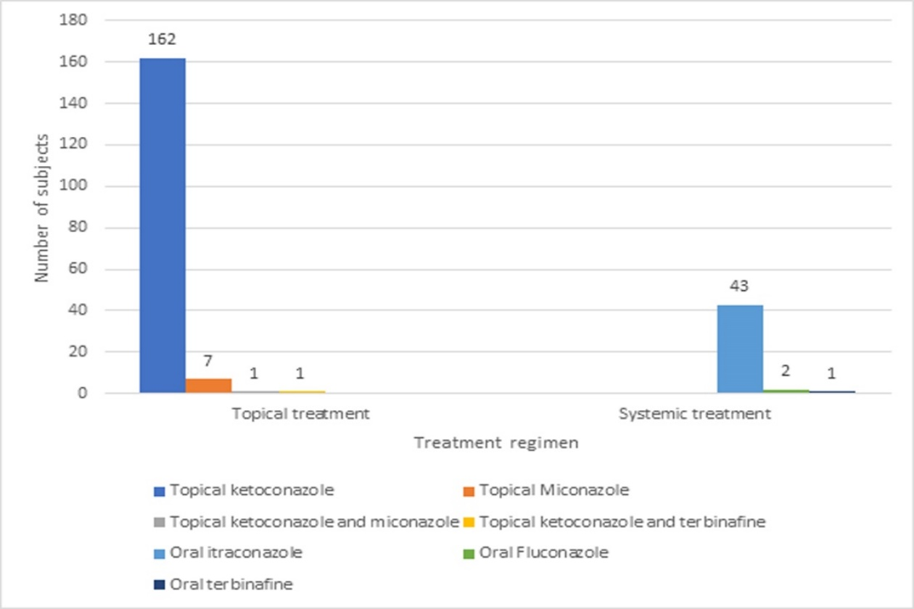
Figure S1. Treatment regimen

