Supplementary File

Supplement to: Naufal MA, Fauzi A, Rengganis I. The efficacy of fetal hemoglobin inducers in adult transfusion-dependent beta-thalassemia patients: a systematic review and meta-analysis. Med J Indones. 2025;34(4):239–51. DOI: https://doi.org/10.13181/mji.oa.257796

This file provides further information related to the study.

Supplementary Information

Supplementary Tables
Table S1. Keywords used in database searching | 2
Supplementary Figures
Figure S1. Risk of bias assessment result | 3

Table S1. Keywords used in database searching
Database | Keywords | Hits
PubMed | ("("thalassemia beta" OR "beta thalassemia"[MeSH] OR "β-Thalassemia") AND (transfusiondependent OR TDBT OR major OR severe) AND ((thalidomide OR "phthalimides"[Mesh]) OR ("butyrates"[Mesh] OR "butyrate" OR sodium dimethylbutyrate OR HQK-1001 OR HQK 1001) OR hydroxyurea OR decitabine) | 34
Cochrane | #1 MeSHdescriptor: [Thalidomide] explodealltrees  #2 MeSHdescriptor: [beta-Thalassemia] explodealltrees  #3 MeSHdescriptor: [Butyrates] explodealltrees  #4 MeSHdescriptor: [Hydroxyurea] explodealltrees  #5 #2 AND ("transfusiondependent" OR "TDBT" OR "transfusion-dependent") AND (#1 OR #3)  #6 MeSHdescriptor: [Decitabine] explodealltrees  #7 #2 AND ("transfusiondependent" OR  "TDBT" OR "major") AND (#1 OR #3 OR #4  OR #6) | 10
Embase | (('beta thalassemia'/exp OR 'beta thalassemia') AND ('transfusiondependentthalassemia'/exp OR 'transfusiondependentthalassemia') OR 'thalassemiamajor'/exp OR 'thalassemiamajor') AND ('butyricacidderivative'/exp OR 'butyricacidderivative' OR 'butyricacid'/exp OR 'butyricacid' OR 'thalidomide'/exp OR thalidomide OR 'decitabine'/exp OR decitabine OR 'hydroxyurea'/exp OR hydroxyurea) AND ([randomizedcontrolledtrial]/lim OR 'controlledclinicaltrial'/de) AND [humans]/lim AND [abstracts]/lim AND [clinical study]/lim | 13

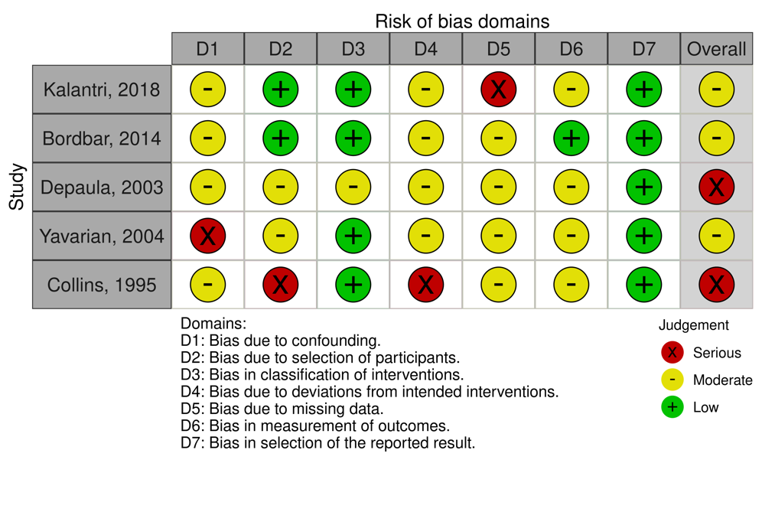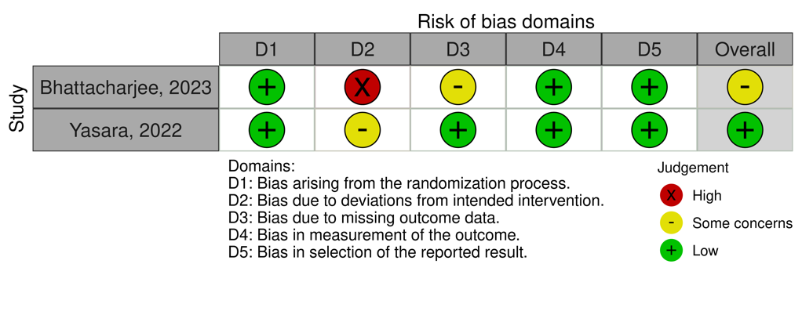
Figure S1. Risk of bias assessment result

